Use-Case Realization Report (Analysis)
Stop Cylinder Production Process

Issue 1.0
Revision History
Date | Issue | Description | Author
29/Apr/2011 | 1.0 | Initial Document | Koh Ming Jin

Table of Contents
1. Brief Description 4
2. Flow of Events 4
2.1 Standard Flow 4
2.2 Exception 4
3. Interaction Diagrams 4
3.1 Collaboration Diagram for Stop Cylinder Production Process 4
4. Participating Objects 4
4.1 Stop Cylinder Production Page 4
4.2 Cylinder Controller 4
4.3 Cylinder 4
5. Class Diagrams 5
5.1 Domain Class Diagram: Stop Cylinder Production Process 5
6. Derived Requirements 5

Use-Case Realization Report
Stop Cylinder Production Process

Brief Description
This use case enables an operation manager to stop cylinder production process.

Flow of Events
The standard flow of events for this use case and any exceptions are described in the following subsections. See section 3.1 for an overview of the participating Actors and Domain Objects.

Standard Flow
The flow of events is described as follows:

- The use case starts when Operation Manager views a list of cylinder processes via Stop Cylinder Production Page.
- The Operation Manager will select which cylinder process to stop and click on the stop button to end the cylinder production process.
- The use case terminates.

Exception
- Unable to stop a process. The actor can only stop a cylinder production process which is currently running. The stop button for any stopped process will be disabled.

Interaction Diagrams

Collaboration Diagram for Stop Cylinder Production Process
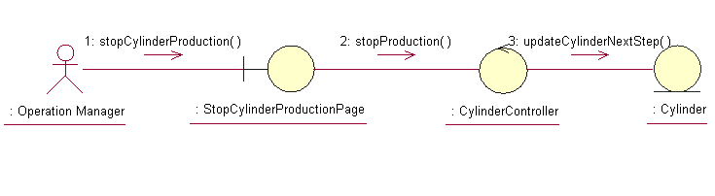

Participating Objects

Stop Cylinder Production Page
This object renders the contents to allow authorized actors to stop the cylinder production request. The Director, Department Manager and Operation Manager actors use this object.

Cylinder Controller
This object acts as the middleman between “Stop Cylinder Production” Page and the Cylinder object. It will translate interactions with the view into actions to be performed by the Cylinder object.

Cylinder
This object stores the details concerning the cylinder information of the COMS.

Class Diagrams

Domain Class Diagram: Stop Cylinder Production Process
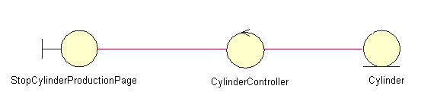

Derived Requirements
The Operation Manager PC keyboard and mouse will be used to enter cylinder production process information details (if any) and view all the system responses.

